qa.purchasingpower.travel

Performance Test report

# **Test Details**

* **Test Date:** 09/05/2019
* **Load:** 5000 Users
* **Duration:** 30 Mins
* **Environment:** qa.purchasingpower.travel

# **Observations & Recommendations**

* All Failures are due to Service Unavailable Error – 503(Service Unavailable Error).
* Application started throwing errors from ~2900 Users.
* For the load of 5000 Concurrent Users, application failure rate is very high.
* Application can support up to 2900 users without failures with optimal performance for “Search – ~70 Seconds & View A Random Hotel – ~60 Seconds”
* **Random View Of Hotels –** Has less number of transactions compared to **Search** due to most of the Searches did not returned any results and thrown errors.
* **Random View Of Hotels** also failed with a higher percentage due to Service Unavailable.

# **Response Time Summary**

|  |  |  |  |  |  |  |  |  |  |
| --- | --- | --- | --- | --- | --- | --- | --- | --- | --- |
|  |  | **Response Time in Seconds** | | | | | | |  |
| **Transaction/Page** | **# Samples** | **Average** | **Median** | **90% Line** | **95% Line** | **99% Line** | **Min** | **Max** | **Error %** |
| 01-OpenURL | 53984 | 59.11 | 58.89 | 115.75 | 137.86 | 171.81 | 0.00 | 203.52 | 28.71% |
| 02-Enter NewYork City | 37531 | 44.26 | 40.93 | 85.14 | 101.41 | 112.84 | 0.22 | 119.44 | 21.50% |
| 03-Search | 27230 | 83.95 | 80.12 | 132.20 | 146.78 | 173.69 | 0.02 | 215.20 | 52.17% |
| 04-RandomView_Hotel | 7085 | 91.21 | 90.42 | 153.84 | 171.31 | 206.26 | 0.00 | 260.45 | 51.84% |
| **API Response Times** | | | | | | | | | |
| 262 /Api/api/Markup/GetMarkupList | 48373 | 15.92 | 10.90 | 40.38 | 46.18 | 60.01 | 0.00 | 60.44 | 10.59% |
| 263 /Api/api/Home/GetHomePageImages | 53976 | 18.21 | 13.10 | 44.27 | 57.17 | 60.01 | 0.00 | 61.49 | 10.22% |
| 273 /Api/api/User/GetPPCUserInfo | 43199 | 16.24 | 10.71 | 42.09 | 50.42 | 60.01 | 0.01 | 60.19 | 6.09% |
| 278 /Api/api/User/GetPPCUserInfo | 40446 | 18.08 | 10.92 | 47.10 | 56.31 | 60.02 | 0.00 | 60.55 | 5.52% |
| 327 /Api/api/Hotels/GetHotelSearchLocationsList | 37531 | 22.48 | 14.66 | 57.23 | 60.01 | 60.03 | 0.22 | 60.41 | 10.11% |
| 328 /Api/api/Hotels/GetHotelSearchLocationsList | 32597 | 24.75 | 16.36 | 60.01 | 60.02 | 60.08 | 0.43 | 60.54 | 13.12% |
| 352 /Api/api/Markup/GetMarkupListByCategory | 22102 | 26.54 | 18.74 | 60.01 | 60.02 | 60.06 | 0.00 | 61.26 | 16.42% |
| 353 /Api/api/Markup/GetMarkupListByCategory | 27230 | 26.16 | 18.14 | 60.01 | 60.02 | 60.07 | 0.00 | 60.41 | 16.61% |
| 354 /Api/api/Hotels/GetResultsWithCacheV2 | 13597 | 25.84 | 17.84 | 60.00 | 60.01 | 60.05 | 0.00 | 60.98 | 14.17% |
| 355 /Api/api/Cart/GetCartItemList | 18082 | 35.07 | 31.52 | 60.02 | 60.04 | 60.12 | 0.07 | 67.31 | 22.83% |
| 400 /Api/api/Cart/GetReturnablePolicy | 5057 | 23.12 | 14.42 | 59.75 | 60.02 | 60.06 | 0.00 | 60.42 | 11.61% |
| 401 /Api/api/Markup/GetMarkupListByCategory | 7070 | 22.87 | 13.88 | 60.00 | 60.01 | 60.01 | 0.00 | 60.26 | 14.33% |
| 402 /Api/api/Markup/GetMarkupListByCategory | 5974 | 23.10 | 13.77 | 60.01 | 60.02 | 60.08 | 0.00 | 60.52 | 14.46% |
| 403 /Api/api/Hotels/GetHotelDetails | 3487 | 23.56 | 14.64 | 58.43 | 60.01 | 60.06 | 0.72 | 60.19 | 10.21% |
| 404 /Api/api/Cart/GetCartItemList | 4412 | 32.64 | 27.36 | 60.02 | 60.03 | 60.10 | 0.74 | 68.37 | 19.33% |

# Response time VS Concurrent users

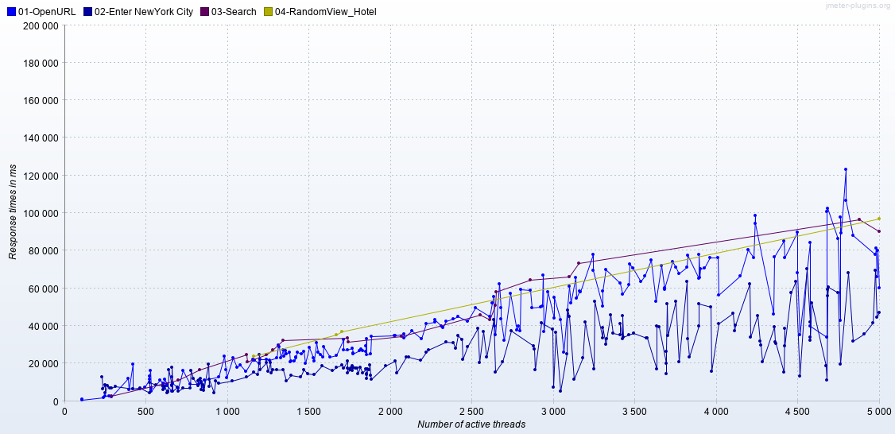

# Random Snap shots of Error

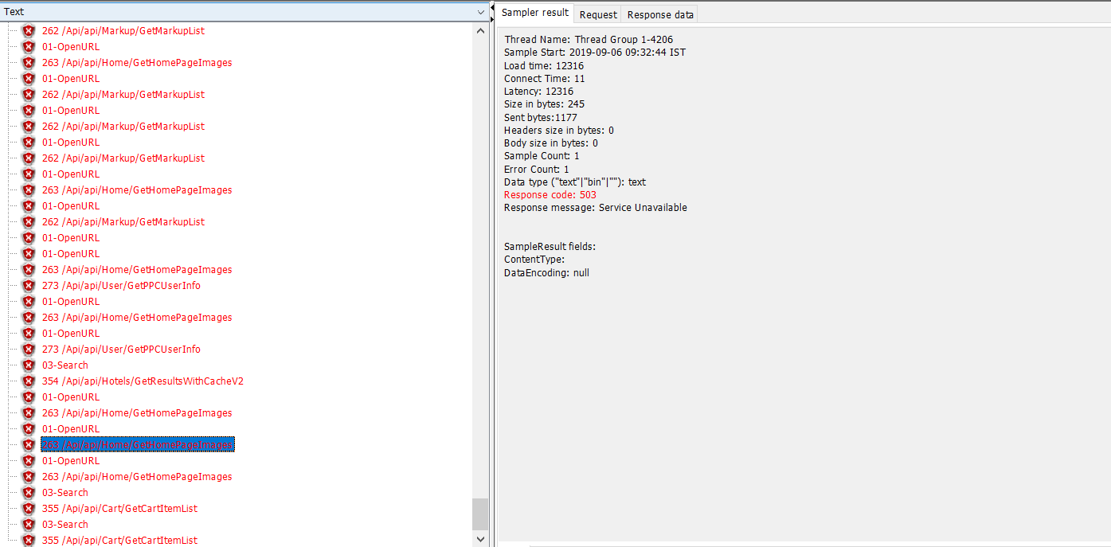

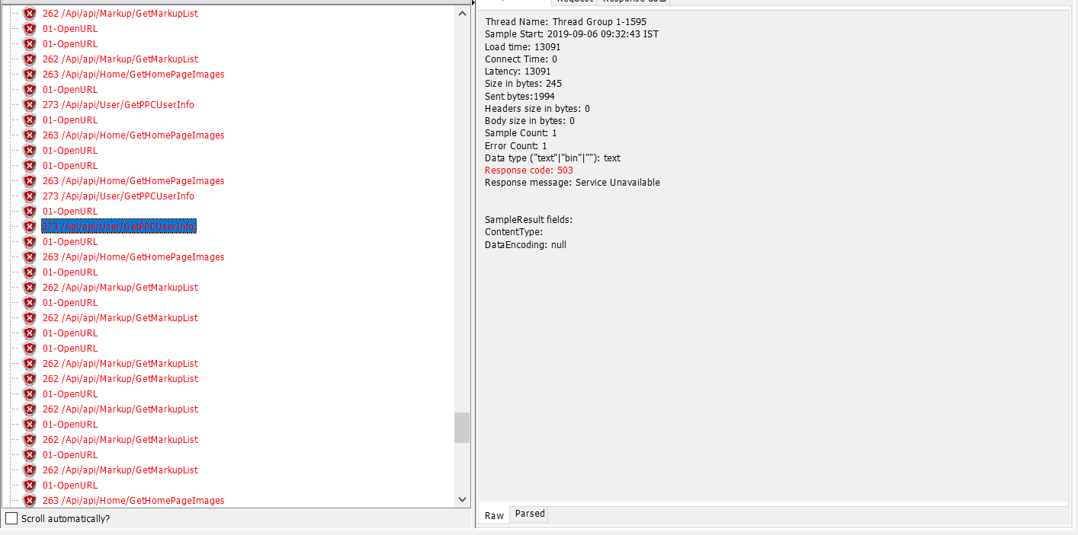

# Errors VS Concurrent Users – Over a Period of time

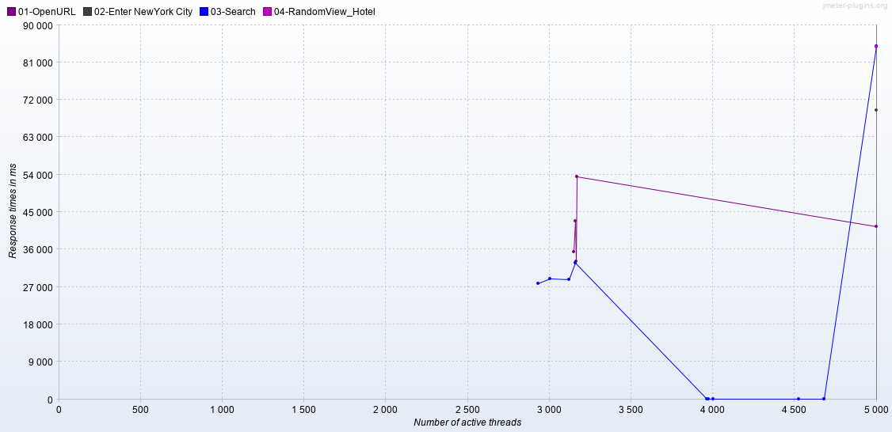

P.S : Ignore Y-Axis Title(Response Times), Just used as a Place Holder. Consider only X-Axis(Number of Active Threads).